Clinical context: H/O Rectal cancer. A/W severe bloating, constipation, Anorexia. CT findings- rectosigmoid irregular thickening, posterior bladder mass + 3 suspicious liver deposit.

Title & Technique: MRI rectum staging protocol (Study quality: Adequate.)

Primary tumour morphology: Semicircular thickening in upper rectum (presumed to be biopsy proven rectal cancer). Involves 11 O' clock to 2 O' clock of rectal circumference.

Location: Distance of distal edge from anorectal junction: 8cm. Height of tumour n(CC extent): Approximately 5.7 cm. Distance of proximal edge form the sigmoid take off: 0.9 cm

Invading edge of the tumour: right anterior lateral as well as posterior.

Muscularis propria: Tumour is crossing the muscularis propria with extramural involvement of the mesorectal fat at multiple places- most easily seen at 5- 11 O' clock location.

Relation to mesorectal fascia: Tumour reaches within 1 mm of mesorectal fascia on the right side (7 O' clock)- MRF+

Relation to the peritoneal reflection (PR): Tumour lies in relation to the the peritoneal reflection and concerning for invasion of peritoneal lining anteriorly.

Malignant lymph nodes: Regional nodes: Atleast 4 Mesorectal nodes noted (measure 5 -7 mm with round shape and indistinct margins). Some of these are located in high mesorectum. Further, a large irregular tumour deposit/ node measuring 3cm , seen in high mesorectum posteriorly - this probably invades fat outside the mesorectum, which will further upgrade the staging to T4b.

Lateral nodes: No lateral (internal iliac/ obturator nodes) seen.

Non regional nodes: No non regional (external iliac, inguinal or common Iliac) nodes seen.

Extramural vascular invasion (EMVI): Present a multiple sites.

Conclusions:

MRF+ rectal cancer - at least T3c but may be T4b (peritoneal involvement and involvement of extramesorectal fat by a high mesorectal tumour deposit).

cN2 with high mesorectal nodes.

Closest circumferential resection margin (CRM):clear

Peritoneal involvement: None

Pelvic sidewall nodes: None

Summary: Semi-circumferential T3/T4a tumour at upper rectum with superior rectal node

Overall stage: T3/4a N1a V0 CRM threatened anteriorly

Recommendation: MDT review

Another good report MRI rectum:

REPORT

Indication:

Rectal bleeding, abnormal bowel habit, abnormal CT scan, rectal mass 5cm from anal verge

Comparison:

CT pancreas 3/5/2024

Technique:

MRI rectum

Report:

Location: Mid-low rectum, centred on the left posterior quadrant

Craniocaudal dimension: 29mm

Distance from anal verge to caudal margin: 28mm

Distance from top of puborectalis to caudal margin: 53mm

Relationship of caudal margin to puborectalis: Above

Relationship to anterior peritoneal reflection: Below

Morphology: Semi-pedunculated polypoid lesion

Signal characteristics: Solid with a thin layer of overlying mucin

Levator involvement: No

Anal sphincter complex involvement: No

T stage: There is a low signal stalk at the base of the lesion at approximately 4 o'clock. The submucosa and muscularis are intact. T1Sm1 at most (if proven malignant)

Mesorectal Nodal Assessment

Total number of radiologically involved regional nodes: None

Nodal staging: N0

Nodal involvement outside of the TME plane: None

Non-regional node involvement: None

EMVI: None

Tumour Deposits: None

Peritoneal Deposits: None

Mesorectal fascia: Not involved

Peritoneal reflection: Not involved

No other significant findings.

Impression:

3cm mid-low rectal polypoid lesion. If proven malignant, suggested local staging no more than T1Sm1 N0.

This could be considered for a local excision strategy.

Lower GI MDT discussion suggested.

# MRI in Rectal Cancer

## Comprehensive Summary of MRI in Rectal Cancer

### Key Points for Reporting

1. **T State**: Determine the primary tumor (T) stage, which includes evaluating the depth of tumor invasion into the rectal wall and beyond.

2. **EMVI**: Assess for extramural vascular invasion, which is a significant prognostic factor indicating the spread of cancer into blood vessels outside the bowel wall.

3. **N State**: Evaluate lymph node involvement (N stage), including the presence of tumor deposits in nodes, which impacts treatment decisions and prognosis.

4. **CRM**: Circumferential resection margin assessment is crucial to ensure clear margins during surgical excision, minimizing the risk of local recurrence.

### High-Resolution T2 Imaging

**Importance**: High-resolution T2-weighted images (HR T2) are the gold standard for evaluating rectal tumors, providing detailed visualization of the rectal wall layers and surrounding structures.

**Technical Specifications**: Typically, a slice thickness of 0.6mm is recommended for optimal resolution.

### Report Templates

**Availability**: Standardized report templates can be downloaded from ARGANZ (Australasian Gastrointestinal Trials Group), ensuring consistent and comprehensive reporting.

### Tumor Regression Grade (mrTRG)

**mrTRG**: MRI-based tumor regression grade (mrTRG) is used to assess the response to neoadjuvant therapy. It is a crucial predictor of long-term outcomes.

**Comparison with pTRG**: mrTRG is not identical to pathological TRG (pTRG) but is a useful biomarker for predicting tumor regression and potential regrowth.

### Restaging and Follow-Up

**Objective**: The aim is to evaluate the effectiveness of treatment and detect any residual disease.

**Key Questions**: When reporting re-staging scans, consider:

- Location of the initial tumor (for comparison with diagnostic scans).

- Presence or absence of residual tumor.

### Post-Treatment Staging (ymr Staging)

**T Stage (ymr T)**: Assess the remaining tumor or fibrosis after treatment.

**N Stage (ymr N)**: Evaluate lymph nodes post-chemoradiotherapy. Nodes that remain visible (>5mm and heterogeneous) are more likely to be positive.

**EMVI Status (ymr EMVI)**: Re-evaluate for any signs of vascular invasion post-treatment.

**CRM Status**: Ensure that the resection margins are clear of any residual tumor.

### Imaging Techniques

**Split Scar Sign**: A positive split scar sign indicates a complete response (mrTRG1). If the line breaks, it might still be a complete response (mrTRG2).

**DWI (Diffusion-Weighted Imaging)**: Useful for identifying residual tumor when matched with T2 abnormalities and low ADC values on ADC maps.

**Indeterminate Areas (TRG 3)**: These areas may benefit from re-imaging to clarify the response.

### Challenges in MRI Interpretation

**Desmoplasia vs. T3 Tumor**: Differentiating between fibrotic tissue and active tumor can be challenging.

**CRM Positivity**: Overcalling CRM positivity should be avoided; T2 disease should not be classified as CRM positive without definitive evidence.

**Lymph Node Assessment**: Nodes should appear abnormal in at least two planes. Morphological features are more critical than size for determining malignancy.

**Fibrosis Identification**: On MRI, fibrosis typically appears darker than tumor tissue, aiding in distinguishing between the two.

### Imaging Highlights

**Visual Aids**: The document includes various images demonstrating critical features of MRI in rectal cancer, emphasizing the importance of high-resolution T2-weighted imaging and the use of specific imaging techniques to distinguish between fibrosis and residual tumor.

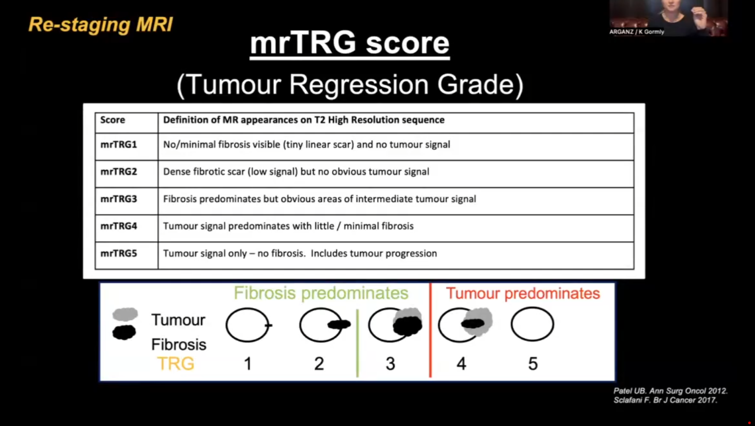

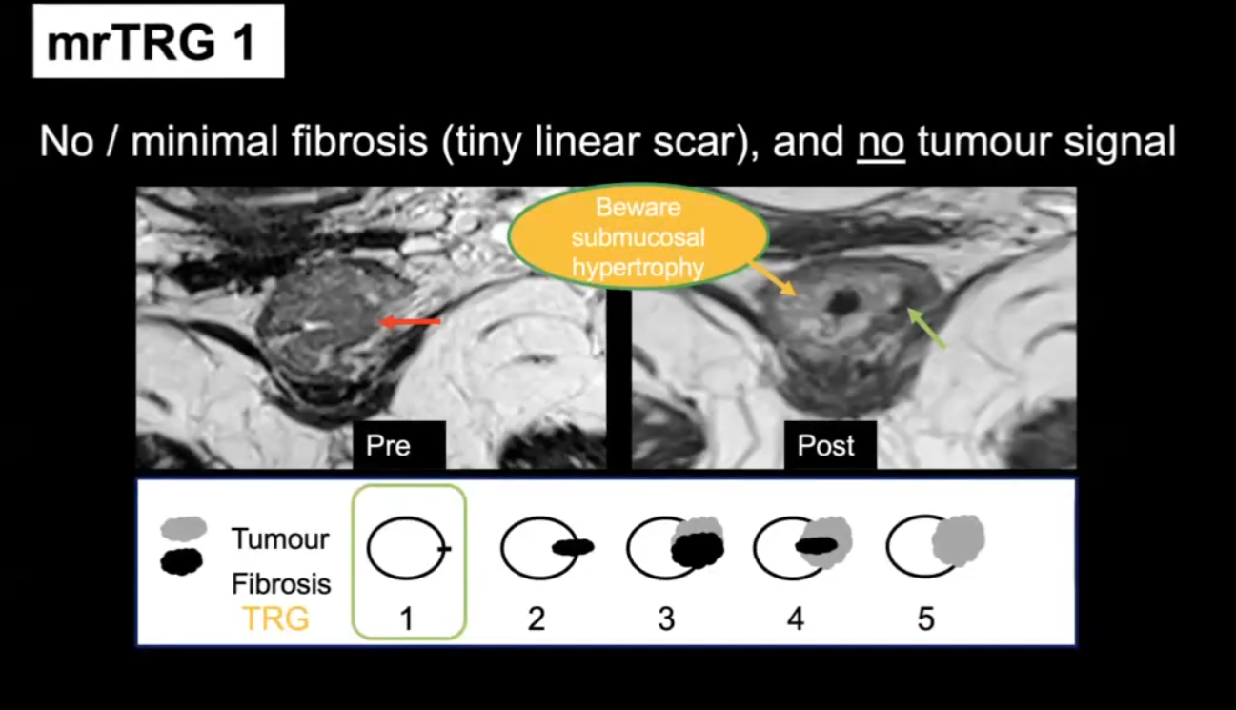

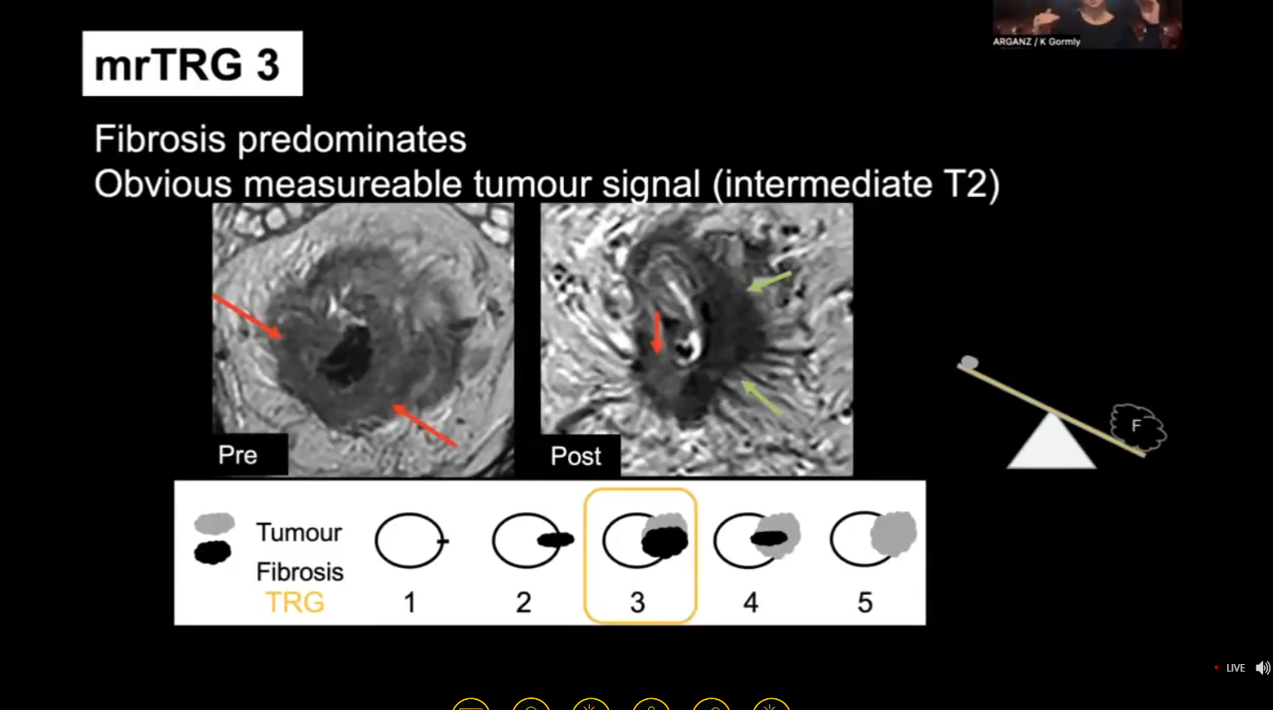

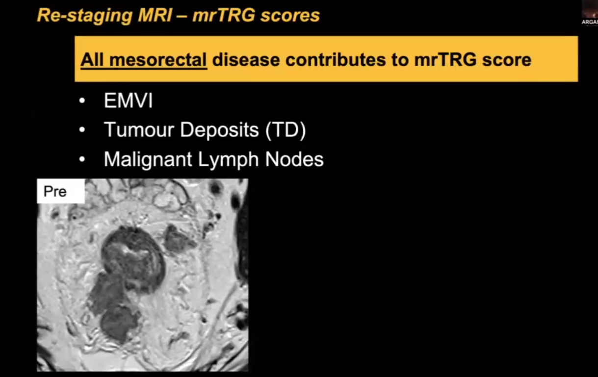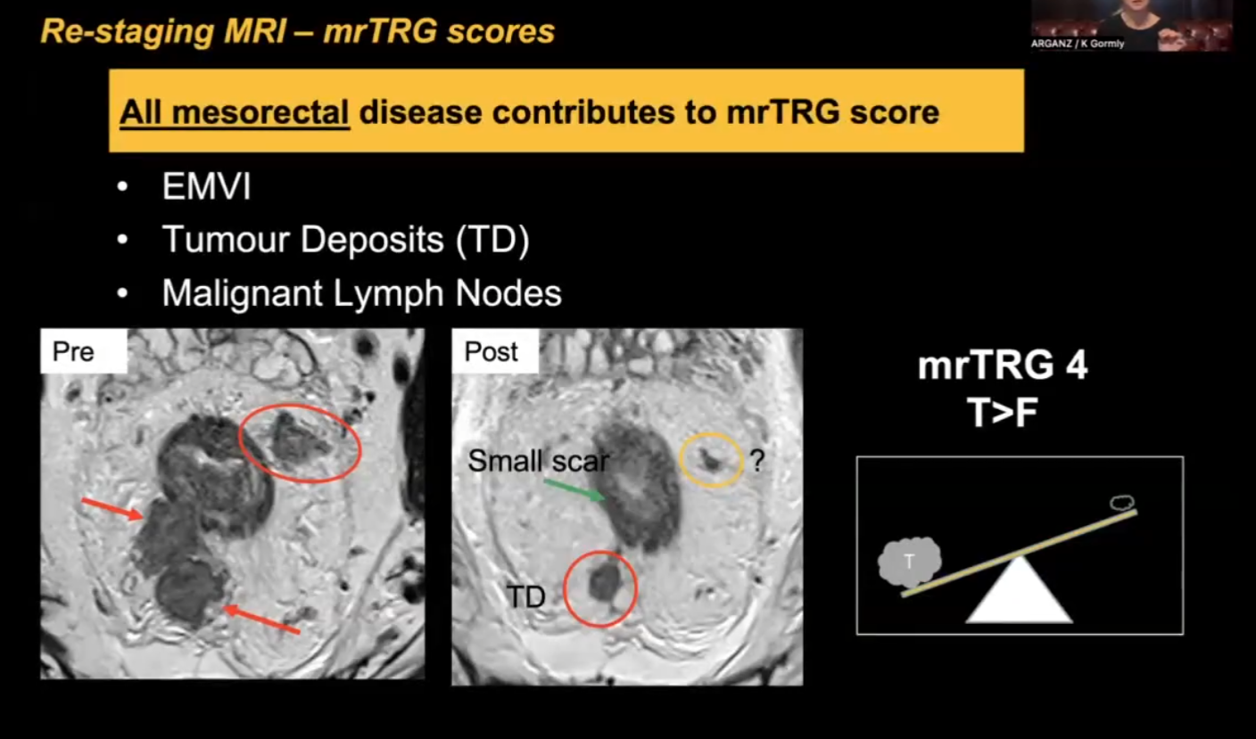

Mucnus tumour – following treatment:  
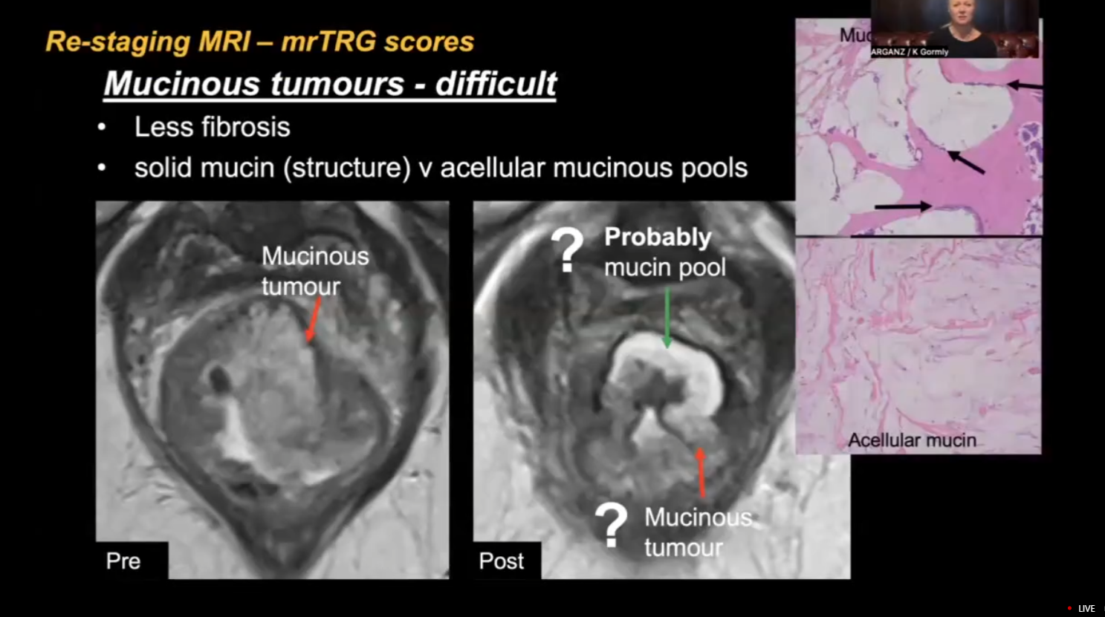

In restating we are predicting outcome and not so bothered about redacting pathology.

mrTRG is not same as pTRG

But it is good biomarker for long term regression and regrowth prediction.

==Split scar sign:

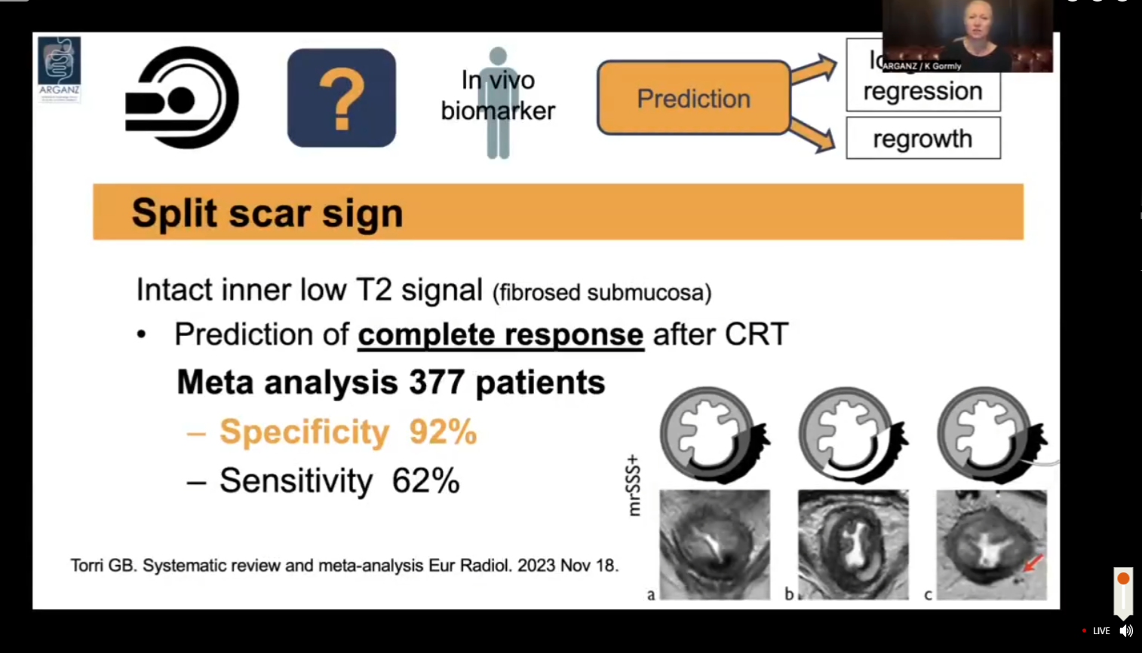

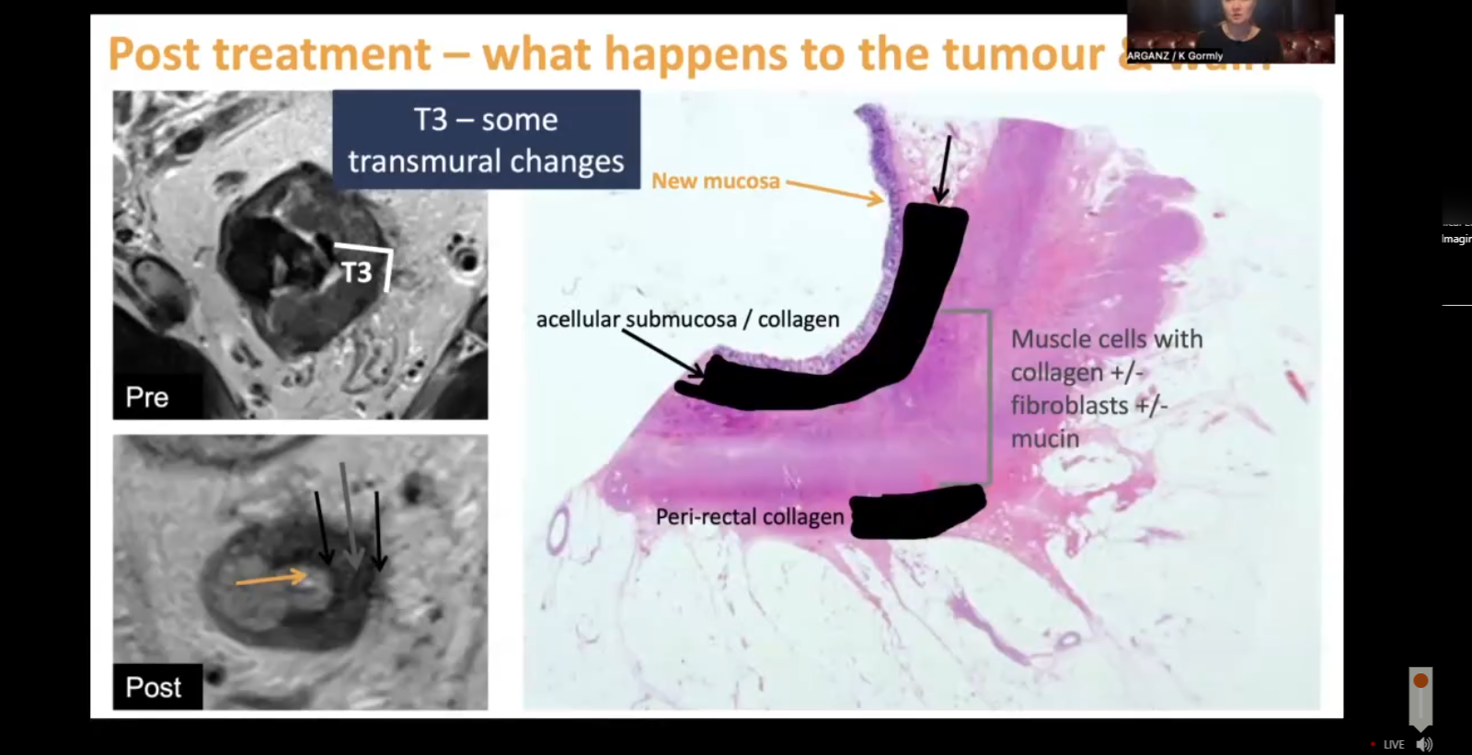

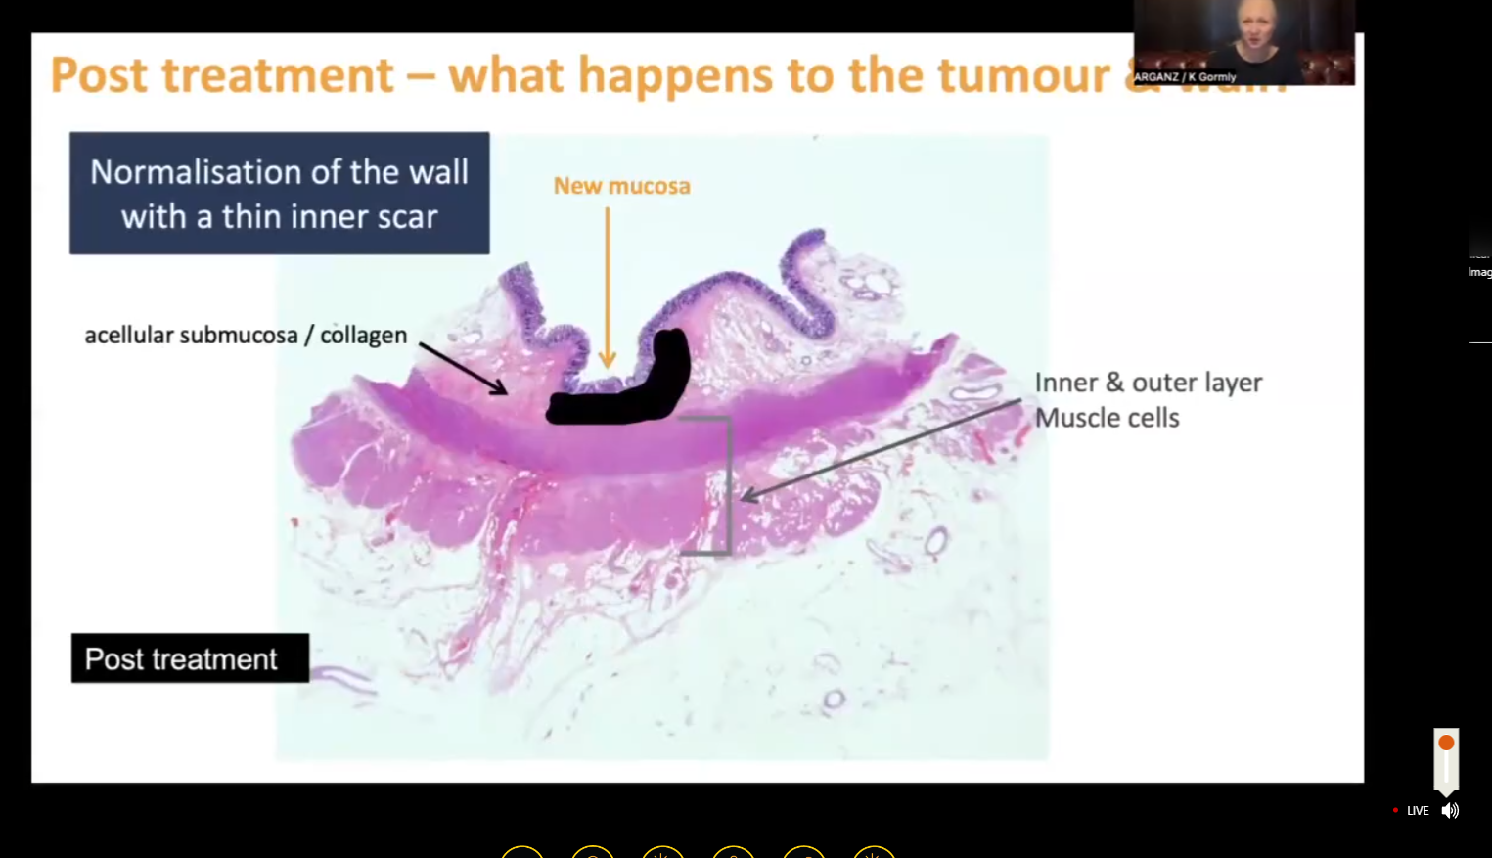

Santiago 1 et al European radiology (3030); 30:224-238 oroignal paper on split scar sign.

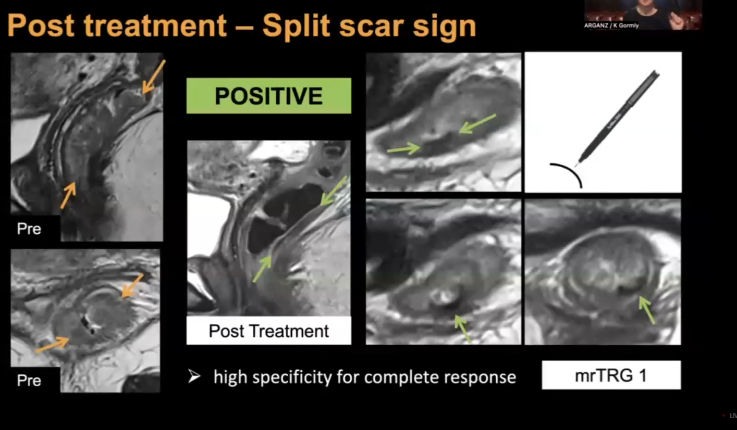

Positive split scar sign- means complete response (mrTRG1).

if the line breaks (see below)- not split scar sign- but still may be complete response. Report as mrTRG 2

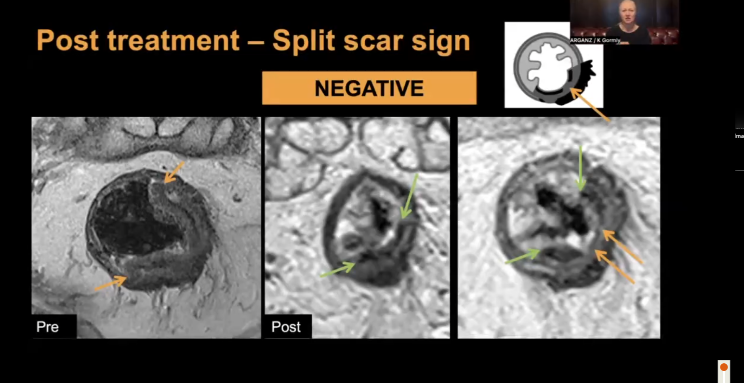

HR T2 (0.6mm) is essential.

DWI is also useful.-:

1. Has to be suite if primary
2. Should have matching T2 abnormality.
3. Matching low ADC in ADC maps.

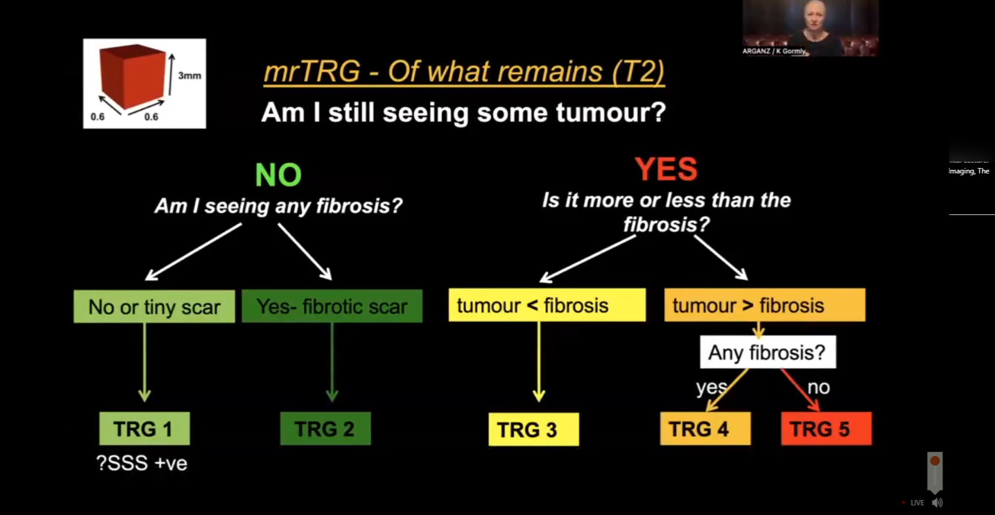

Indetermiate area is TRG 3:- may be helpful to reimage:

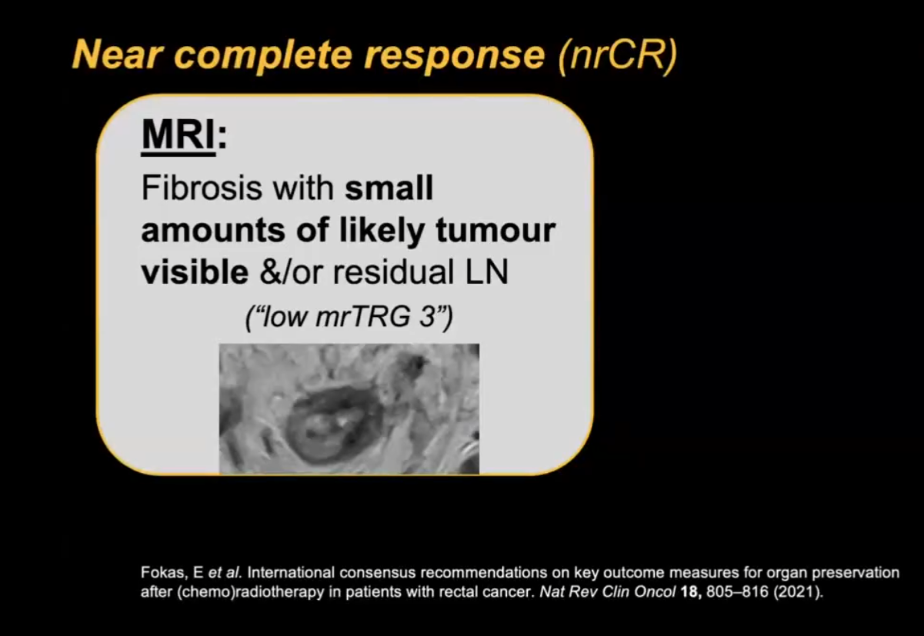

Difficult areas:

* Desmoplasias v/s T3
* Overcalling CRM +ve= T2 disease can not be CTRM +ve.
* Node- difficult- should look abnormal in two planes. Morphology and not size is criterion.
* mrTRG -: fibrosis is much more darker then tumour.